1. Background

As a rookie of IT domain. I felt it was so hard to handle with the basic concepts of IT programming languages such as Java, Python, Nodejs and so on as well as some protocols and principles in network. I studied civil engineer before I came USYD, but I am so interested in learning new things in new area of IT. A quiz in game style that can also be called a mind sport can help students or spur them to attempt to answer questions in handset. In this way, rookies of IT could build confidence and motivation for learning boring theory.

1. Market analyze
   1. Customer analyze

With increasing the number of riders, users would like to find one application on mobile to review the knowledge and simulate the real test. It is convenient for them to finish the course of rider’s knowledge and review the test even in the bus or toilet. Driver knowledge test is a strict test, which means riders or drivers cannnot lose more than two scores in each part. And about the knowledge, it has ten section to supply user testing. After riders learning, they may want to get one application to test themselves. That is why we contribute our efforts to deal with this application.

* 1. Competitor analyze

Before I create ‘quiz app for IT rookies’, I have done a research about characteristics of good feedback which may the most important elements of improving productivity of learning new things. I will make a comparison with two apps in quiz subclass. All of them are free for users.

**1)Quizlet(Inc, 2017)**

In Quizlet, the users could practice and master knowledge more interesting. The users can create their own flashcards and study sets or choose from millions created by other students. More than 20 million students study with Quizlet each month that makes studying languages, history, vocabulary and science more simple and effective. Study are companying with charts, maps, images and figures

**2) Solo Learn(Python, 2017)**

Solo learn collected 12 programming languages, including Python, HTML, CSS, JavaScript, C++, Java, PHP, SQL, Ruby, JQuery, C#, Swift. the users can learn all the programming languages listed above through interactive lessons, code in the mobile code playground, play with friends and peers, and discuss to learn or help others learn.

Two apps I mentioned before are both fantastic for users. But for Quizlet, developing images and cards is not suitable for learning IT. Coding stuff is the main points in IT domain. For Solo Learn, it provides a super fantastic interface for users to program in any mobile platform, which will be a very creative way to learn programming. But it does not provide more details in IT theory and no quiz after that which may be the only shortcoming for this app.

For my own app, it does not simply show “right” or “wrong” outcome is not enough, which makes no difference for learner’s knowledge retention. The main characteristic of my app is good feedback that targets to specific error — it shows the learner the connection between

* 1. Product analyze

After searching from website and enquiring motorbike riders, we decide to build our product “DKT Hero”. We reorganise the test bank and provide two main functions that others do not have. They are “Test bank” and “Best score”.

Our product redesigns the interface of driver knowledge test whose performance and designing can make application easily understanding and multifunctional.

Briefly introducing, users can use “Test bank” to do some simulation and review the weak knowledge. After users finishing one test, the system will record the result of exam. Then users can go to the next button “Best score” to check which part or section is the weakness. This is our highlight designing, because driver knowledge test is not only about learner’s score, but also the safety of road. So, drivers or riders must remember all details of transport rules. Some part of test will not give learners a chance to make mistakes. That is why we design “Best score” to remind users.

Problems and Solution

**3.1 Problems**

I have searched many quiz apps for my project model but I failed to find a quiz app for IT rookies. Frankly speaking, I am a rookie in this domain, but I have full energy to learn new things in IT domain. Although I am working hard for get daily job done, if I have a proper way to review my knowledge anytime and anywhere, I can grow up fast every day. During this term, I have a chance to design an IOS app for myself in mobile computing in order to help other rookies like me to build confidence in IT learning.

**3.2 Solutions**

This quiz app for IT rookies will be test among my classmates. All concepts and skills will range from basic to excellent level. The flowchart below shows the implementation and demonstration of login in process and using the application.

1. Functions Overview

(details can refer to the manual)

* Login:

We use Facebook login model to record candidates’ information. In login page, we add one advertisement below, meawhile in the end of test, there is also one advertisement showing there.

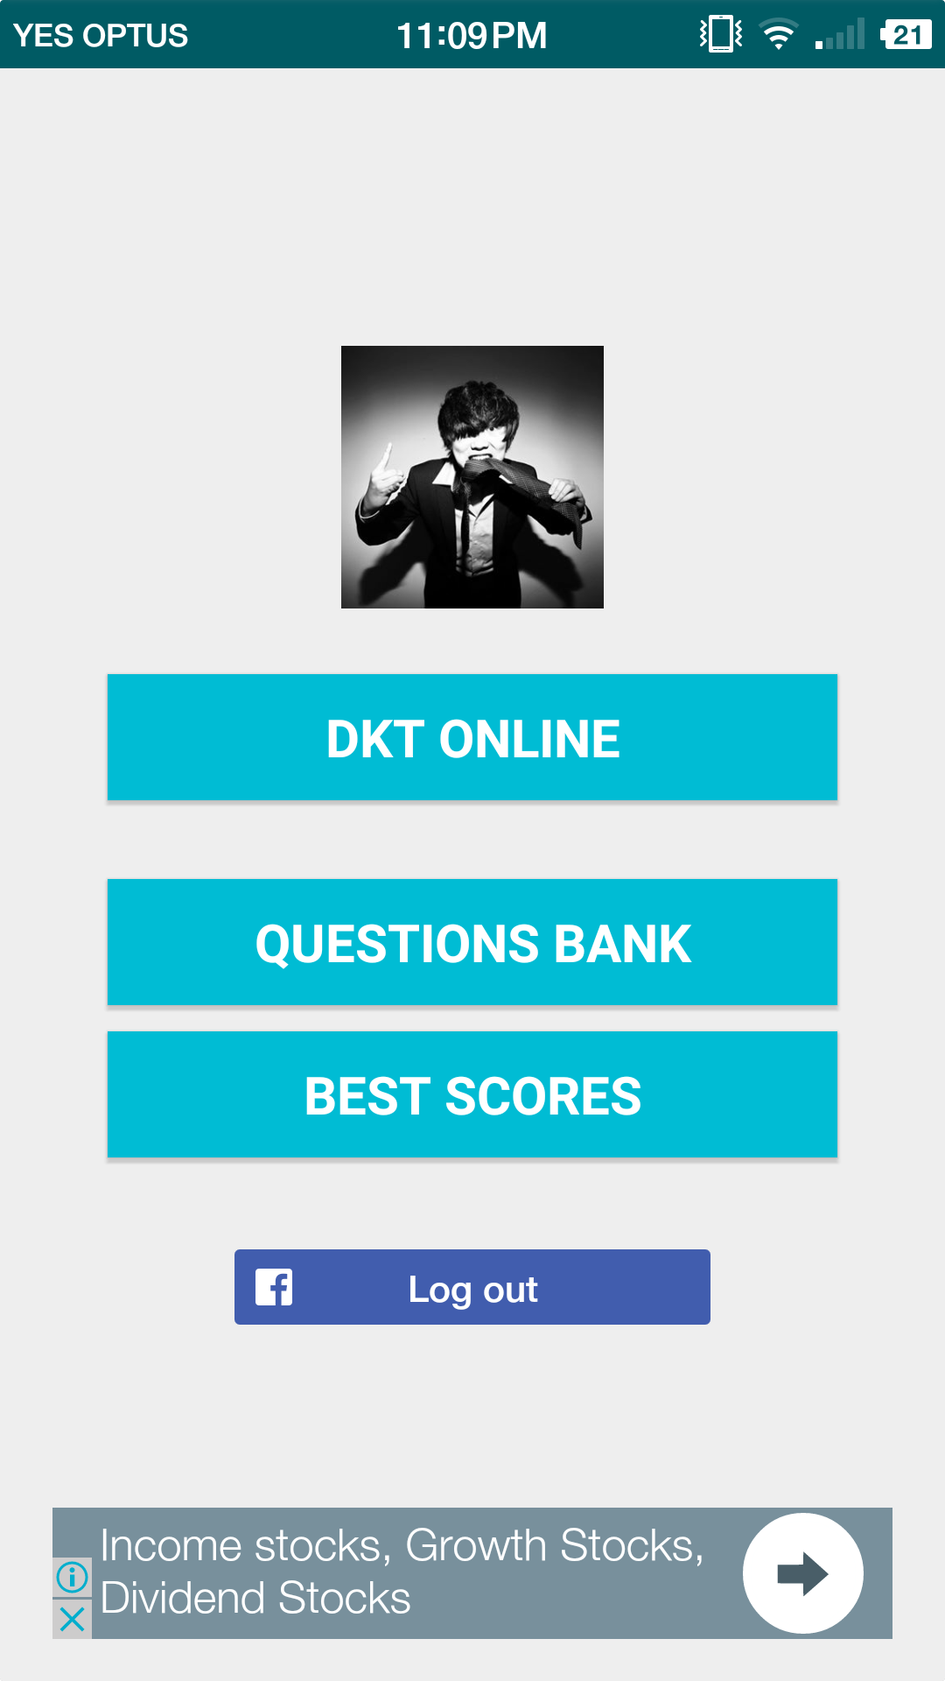 

Figure1. Login with Facebook. Figure2. DKT Online test.

* DKT Online

This button links to the official website to do simulating test. Users do not need to remember the address of DKT website.

* Question Bank

This function collects every question in each section of question bank. Candidates can use this function to practice and review the points. The result will record into next button “Best score”.

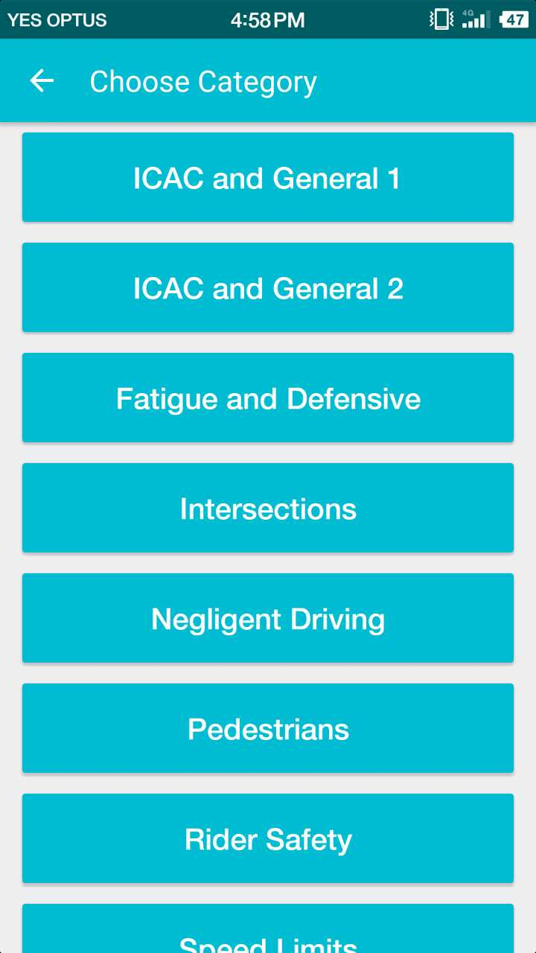 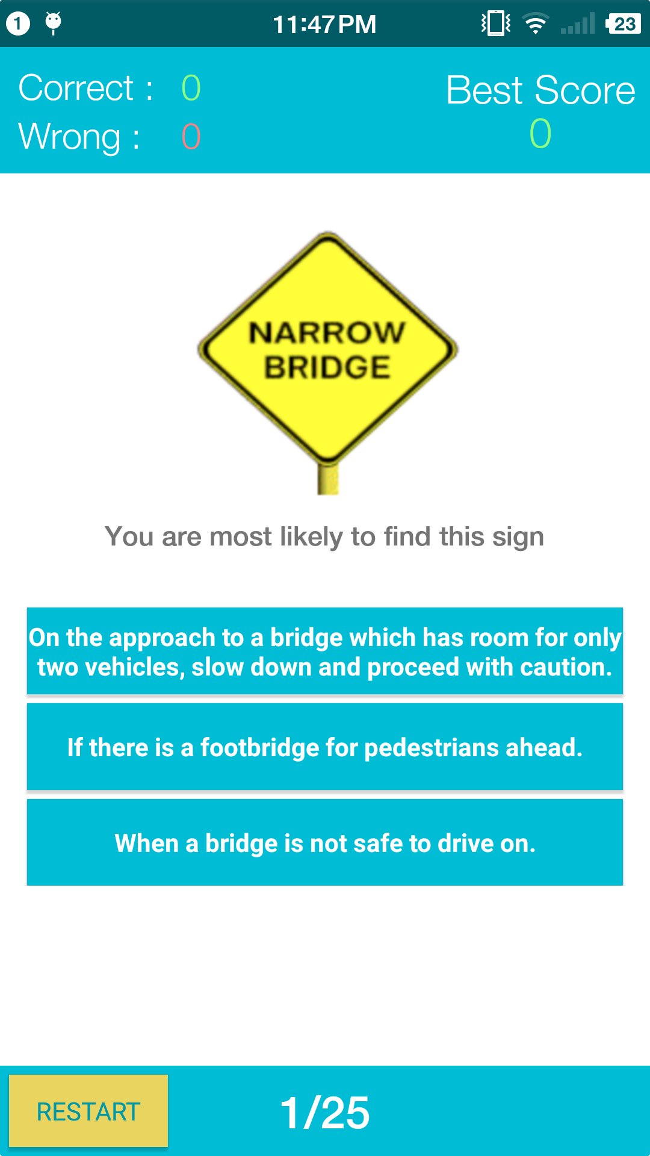

Figure3. Question bank. Figure4. Question display

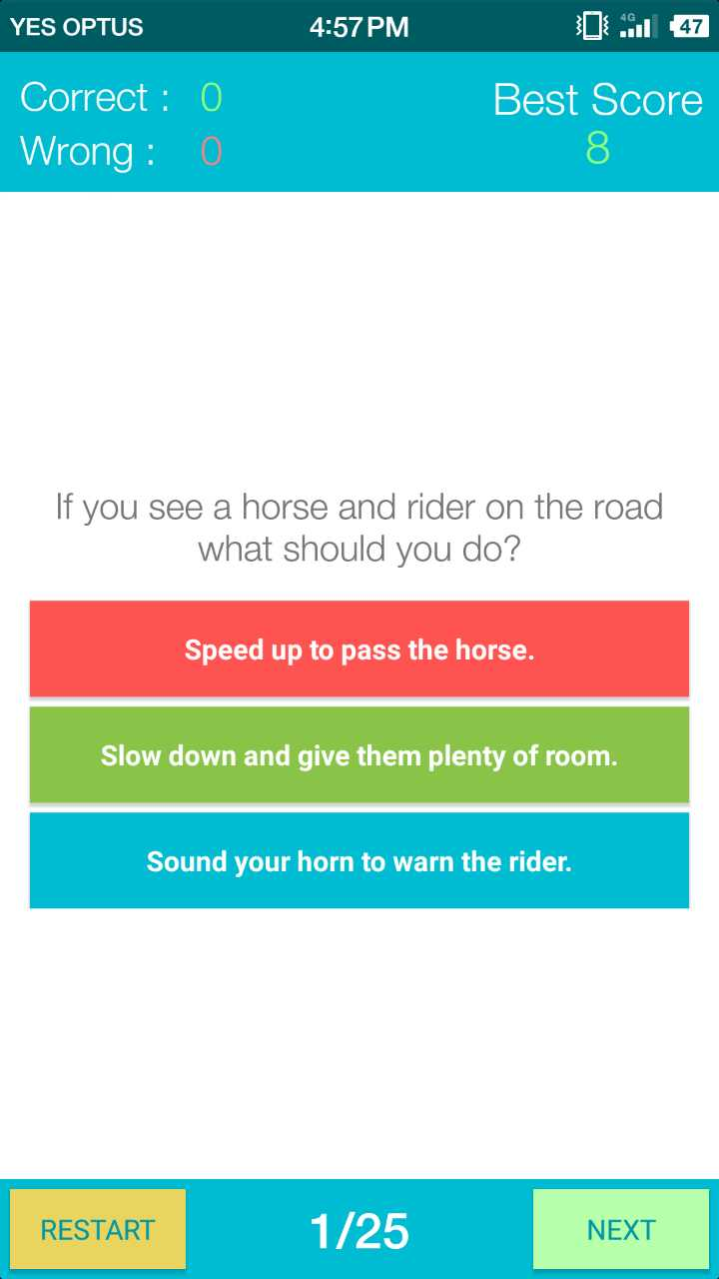 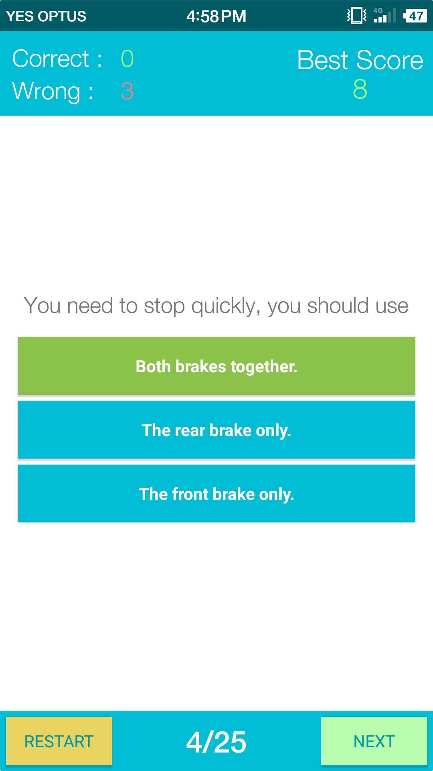Figure5. Question bank with wrong answer. Figure6. Question with right answer.

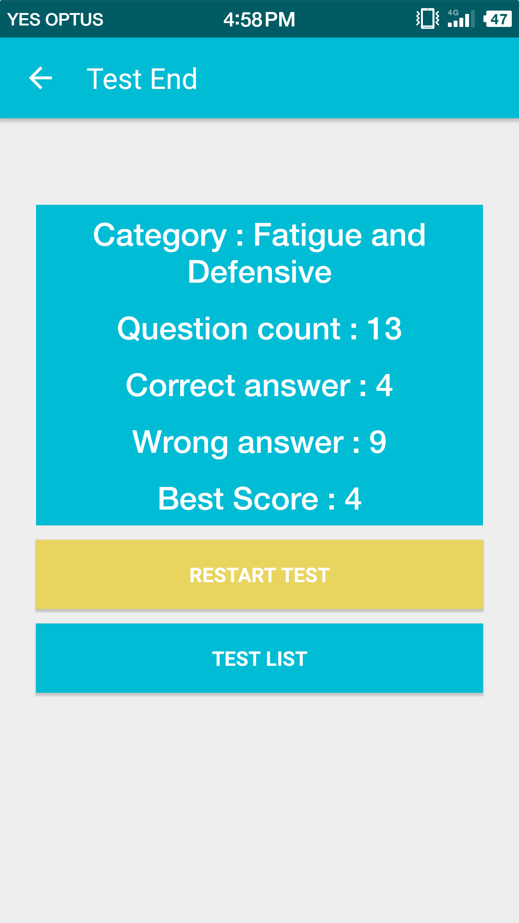 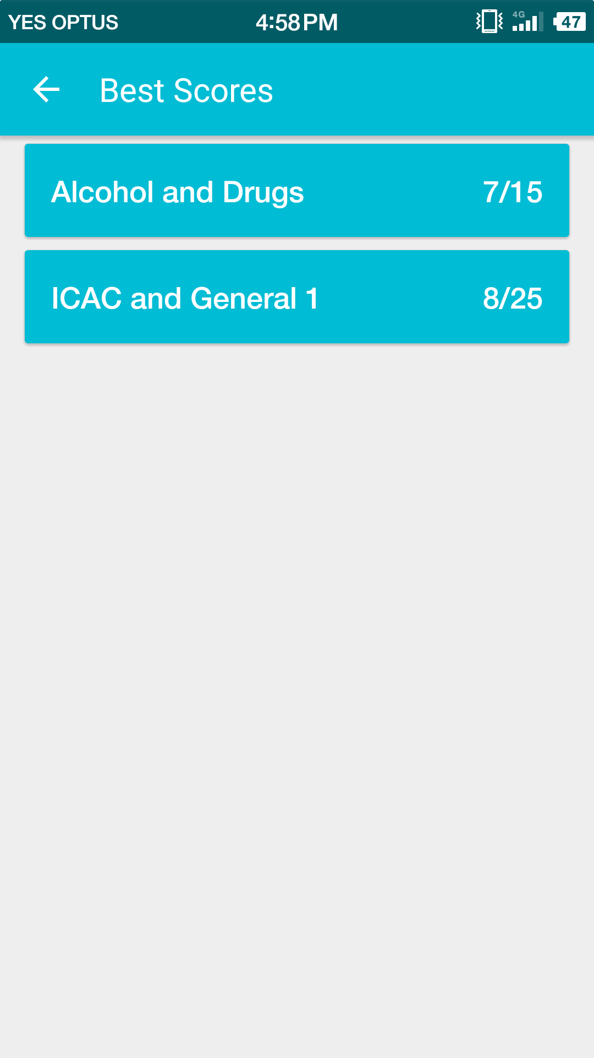

Figure7. Test bank result. Figure8. Best score.

* Best Score

“Best score” can show which part need to be reviewed and which part may lose scores in real test. Remind users and help users to go back to bank and train again.

1. Flow chart diagram

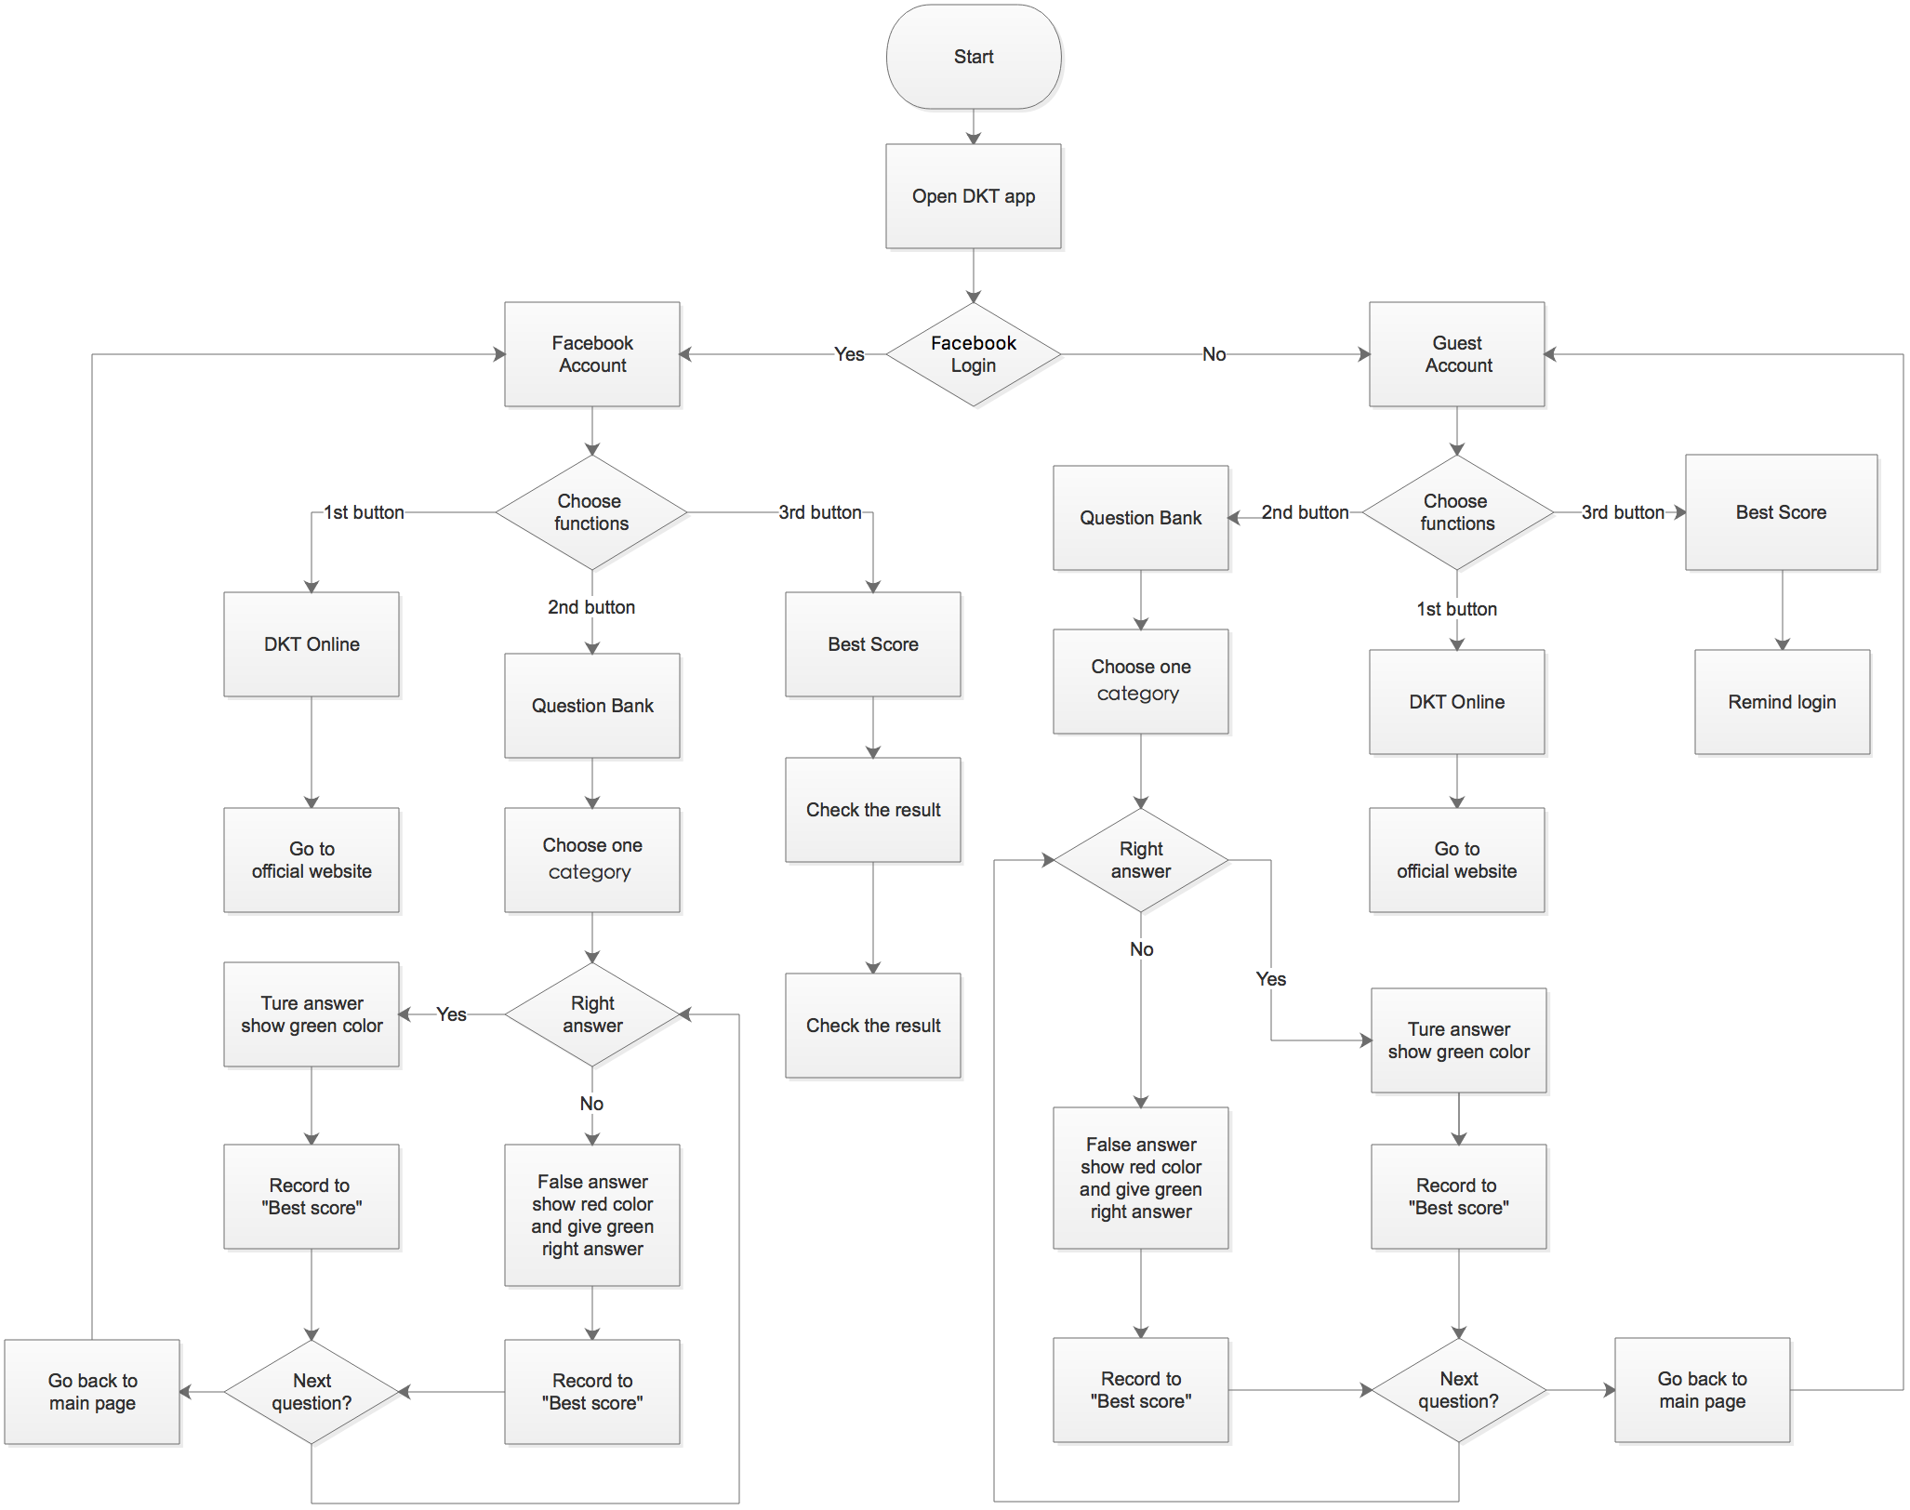

figure9. The diagram of DKT app.

1. Reflection and outlook

In this project, we found many useful resources on the websites. The most authority one is the official document on developer.android.com. We have also learned some knowledge and personal practice experience about Android developing from many blogs any other Android developers, They are very helpful. We have read several chapters of two books, one is “Android design patterns: interaction design solutions for developers” written by Nudelman, Greg, we have learned some concept about the user interface and interaction design from this book. Another one is “Learn Android Studio: build Android apps quickly and effectively” written by Gerber, Adam; Craig, Clifton, we have learned about some important structure and components in this book.

We realy hope this app can help some learners in studying driving or riding. At first, this is a problem about personal safety in transportation. Secondly, this app “DKT-Hero” can realy give candidates a feedback about test result and remind users to review the corresponding sections. Finally, we hope our product can go to the application market and test firstly freely. Then collect the feedback from customers and do some improvement. We suppose that the next step is arranging the database of test bank and adding more than one language in system, such as Spanish, Japanese and Chinese. In question bank, owing to the lack of time, we just finished the motorbike question bank. In our next version, we will add some kinds like cars test. Finally, popularize this application in public and try to cooperate with government to set this app officially.

1. Reference

Australian Bureau of Statistics. (2011). "Motor Vehicle Census cat no. 9309.0." cat no. 9309.0.Retrieved 20 December 2011, *from*

*http://www.abs.gov.au/ausstats/abs@.nsf/mf/9309.0*

Share, I.S.O.M. Q1 2015, 2015. *URL http://www.idc.com/prodserv/smartphone-os-market-share.jsp*